Lab File
On
Digital Electronics And Computer Organisation

Submitted To
Ms Neha Arora
Amity University Uttar Pradesh



In partial fulfilment of the requirements for the award degree of
Bachelor of Technology
In
Artificial Intelligence
by
Priyansh Jain
A023119820019

DEPARTMENT OF COMPUTER SCIENCE AND ENGINEERING
AMITY SCHOOL OF ENGINEERING AND TECHNOLOGY
AMITY UNIVERSITY UTTAR PRADESH
NOIDA (U.P)

INDEX

S NO | AIM | DATE | FACULTY’S SIGNATURE
1 | Verification and interpretation of truth tables for various logical gates. | 07-01-2022
2 | Construction of full adder and half adder using NAND and XOR gates. | 14-01-2022
3 | Construction of half subtractor and full subtractor using NAND and XOR gates. | 21-01-2022
4 | To implement a 4-bit binary adder-subtractor circuit. | 04-02-2022
5 | To implement arithmetic logic unit using multiplexer and decoders.
6
7
8
9
10

Experiment Number: 1
AIM: Verification and interpretation of truth tables for various logical gates.
PLATFORM/TOOLS USED:
- Virtual Lab
- circuitverse.org
THEORY:
Logic gates are the basic building blocks of any digital system. Logic gates are electronic circuits having one or more than one input and only one output. The relationship between the input and the output is based on a certain logic. Based on this, logic gates are named as
- AND gate
- OR gate
- NOT gate
- NAND gate
- NOR gate
- Ex-OR gate
- Ex-NOR gate

- AND gate:

Truth table
A | B | Y=A.B
0 | 0 | 0
0 | 1 | 0
1 | 0 | 0
1 | 1 | 1

KMAP

A
B

0
0
0
0
0
1

1
1
Expression: Y=A.B
Symbol:
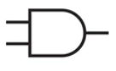
IC No: 7408

- OR gate:

Truth table
A | B | Y=A+B
0 | 0 | 0
0 | 1 | 1
1 | 0 | 1
1 | 1 | 1

A
B

0

1
0

1
0
1
1
1
Expression: Y=A+B
Symbol:
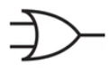
IC No: 7432
- NOT gate:

Truth table
A | Y
0 | 1
1 | 0

Expression: Y=A+B
Symbol:
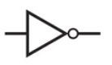
IC No: 7404

- NAND gate:
Truth table
A | B | Y=(AB)’
0 | 0 | 1
0 | 1 | 1
1 | 0 | 1
1 | 1 | 0

A
B

0

1
1
1
0
1
0
1

Expression: Y=(AB)’
Symbol:
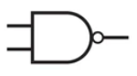
IC No: 7400

- NOR gate:
Truth table
A | B | Y=(A+B)’
0 | 0 | 1
0 | 1 | 0
1 | 0 | 0
1 | 1 | 0

A
B

0

0
1
0
0
1
0
1
Expression: Y=(A+B)’
Symbol:

IC No: 7402

- XOR:
Truth table
A | B | Y=A.B
0 | 0 | 0
0 | 1 | 1
1 | 0 | 1
1 | 1 | 0

A
B

0

1
0

1
0
1
0
1
Expression: Y=A XOR B
Symbol:
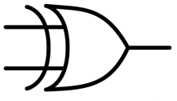
IC No: 7486

- XNOR:
Truth table
A | B | Y=A.B
0 | 0 | 1
0 | 1 | 0
1 | 0 | 0
1 | 1 | 1

A
B

0
0

1
0
0
1

1
1
Expression: Y=A XNOR B
Symbol:


RESULT:

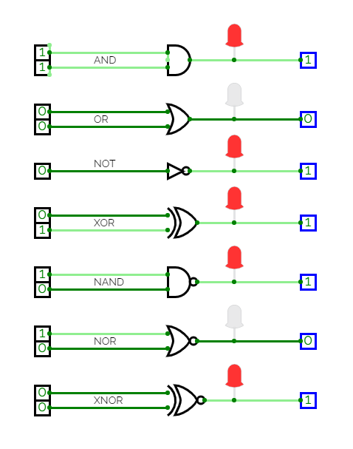

CONCLUSION: The logic and universal gates’ truth tables are verified.

CRITERIA | TOTAL MARKS | MARKS OBTAINED | COMMENTS
Concept (A) | 2
Implementation (B) | 2
Performance ( C ) | 2
TOTAL | 6

Experiment Number: 2
AIM: Construction of full adder and half adder using NAND and XOR gates.
PLATFORM/TOOLS USED:
- Virtual Lab
- circuitverse.org
THEORY:
Half-Adder is a combinational circuit that can be used to add two binary inputs. It has two inputs that represent the two bits to be added and two outputs, with one producing the SUM output and the other producing the CARRY.

Truth table of half-adder

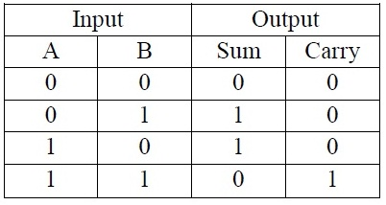

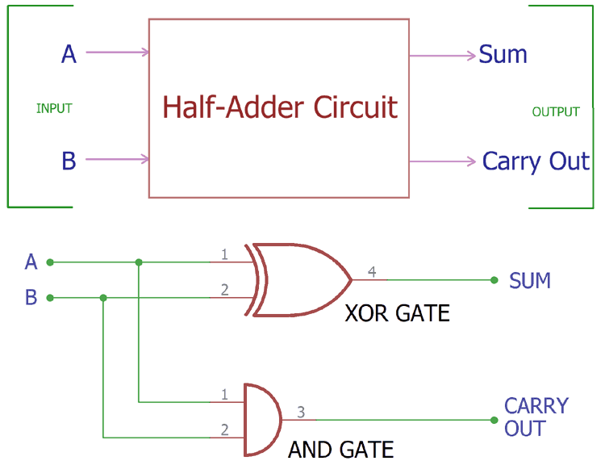

K-map for half-adder

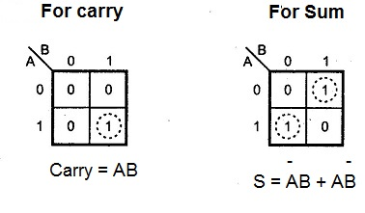
Full-adder is the adder which adds three inputs and produces two outputs. The first two inputs are A and B and the third input is an input carry as C-IN. The output carry is designated as C-OUT and the normal output is designated as S which is SUM.

Truth table for full-adder

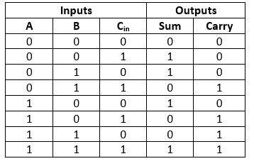
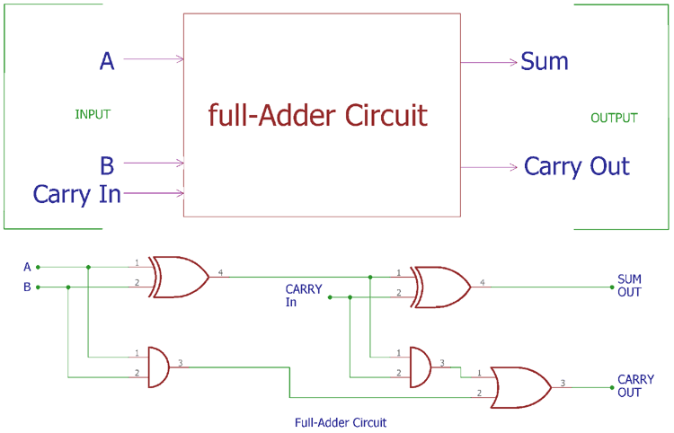

K-map for full-adder

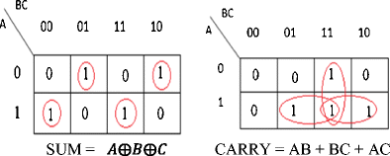

RESULT:

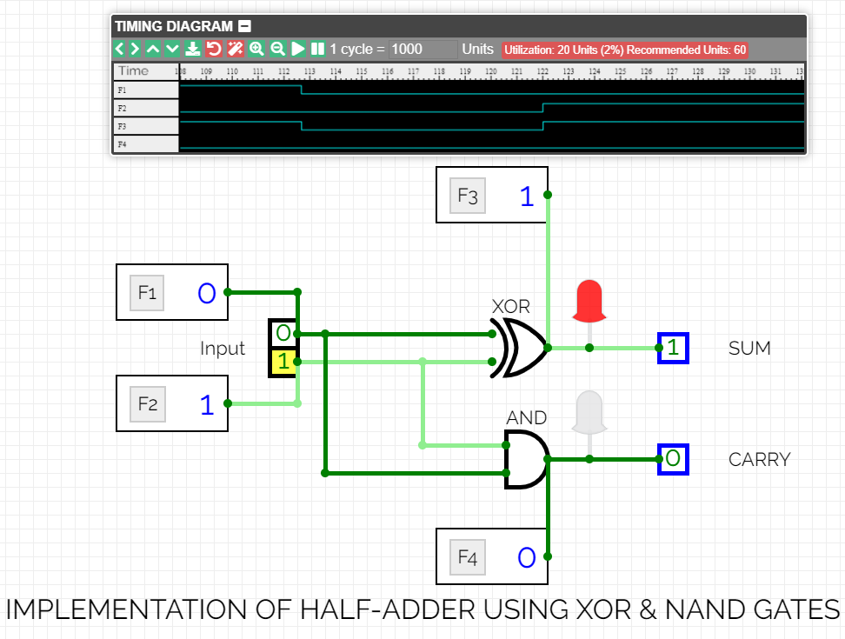

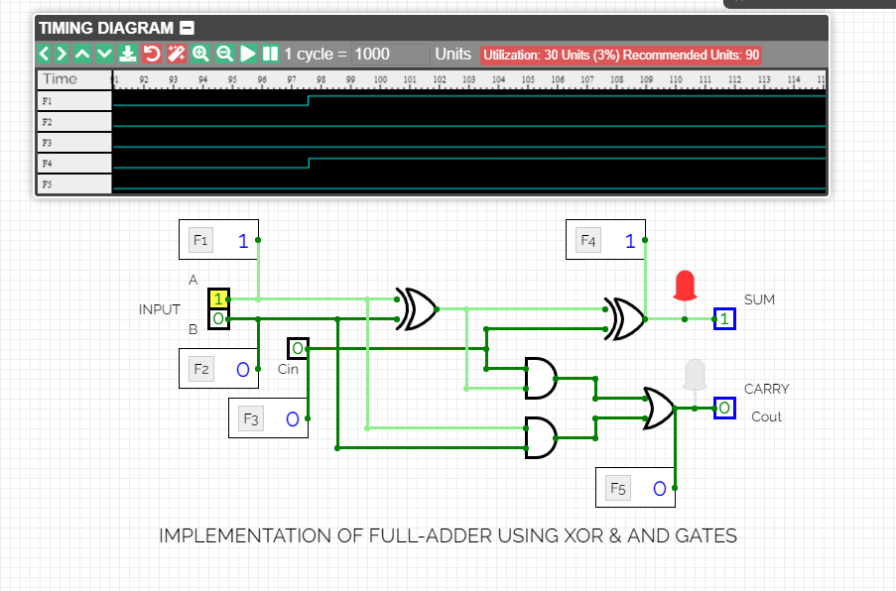
CONCLUSIONS: The full adder and half adder are successfully constructed.

CRITERIA | TOTAL MARKS | MARKS OBTAINED | COMMENTS
Concept (A) | 2
Implementation (B) | 2
Performance (C) | 2
TOTAL | 6

EXPERIMENT: 3A

AIM: Construction of half subtractor combinational circuit using:
- AND and XOR gates
- NAND gates

PLATFORM/TOOLS USED: circuitverse.org

THEORY:
Half-Subtractor is a combinational circuit that can be used to subtract two binary inputs. It has two inputs that represent the two bits to be subtracted and two outputs, with one producing the DIFFERENCE output and the other producing the BORROW.

Truth table for half-subtractor:

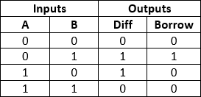

K-maps for half-subtractor:

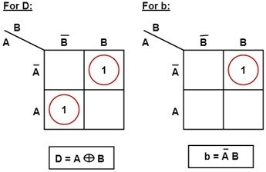

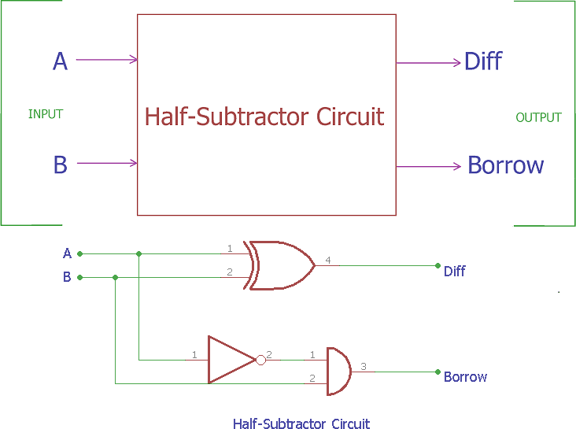

RESULT:
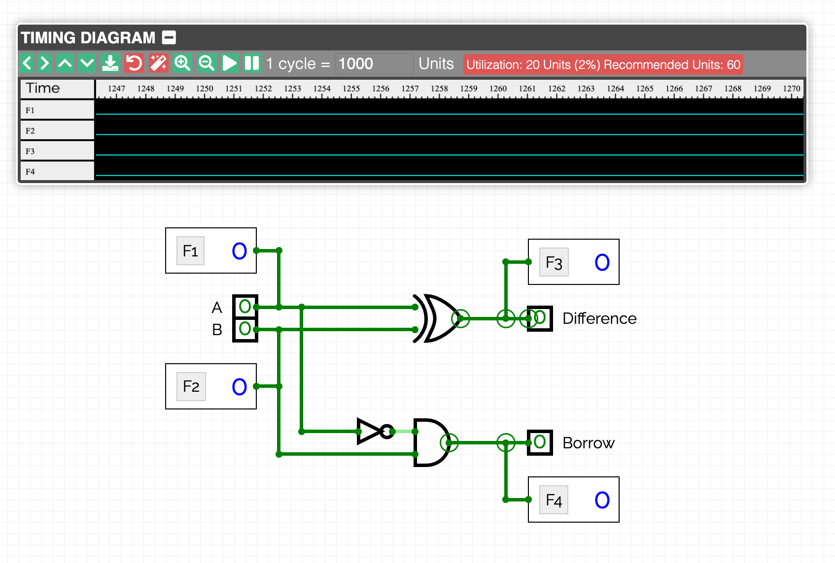

(Half-subtractor combinational circuit using AND and XOR gates)
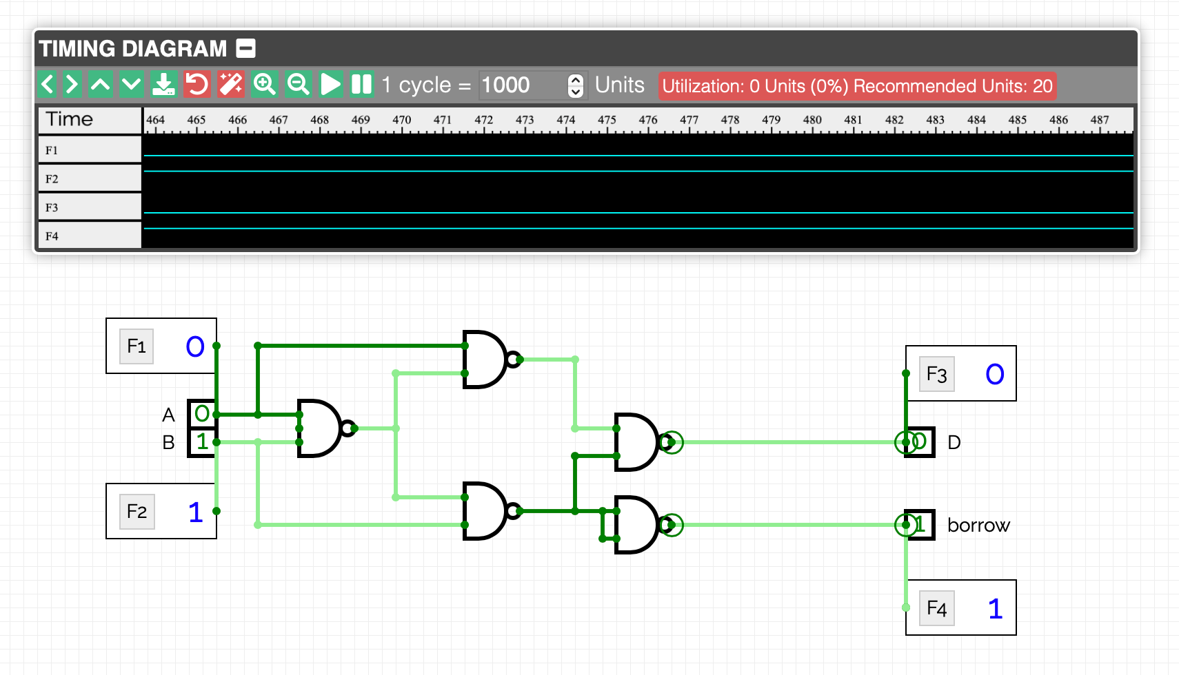

(Half-subtractor combinational circuit using NAND gates)

EXPERIMENT: 3B

AIM: Construction of full- subtractor combinational circuit using:
- AND and XOR gates
- NAND gates

THEORY:
Full-Subtractor subtracts three inputs and produces two outputs. The first two inputs are A and B and the third input is an input Borrow as B-in. The output Borrow is designated as B-out and the normal output is designated as D which is Difference.

Truth table for full-subtractor:
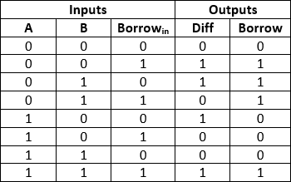

K-map for full-subtractor:

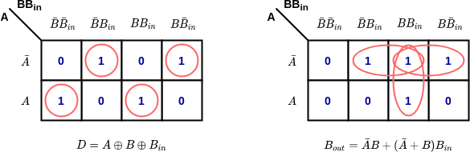

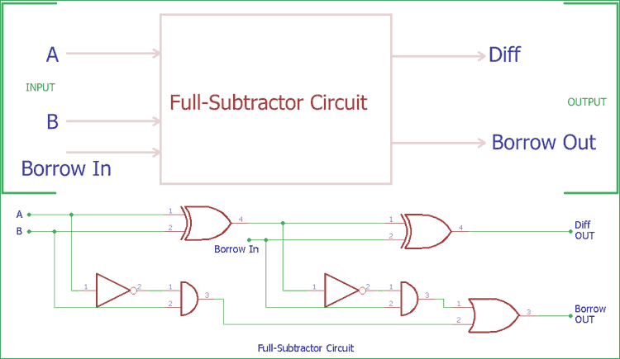

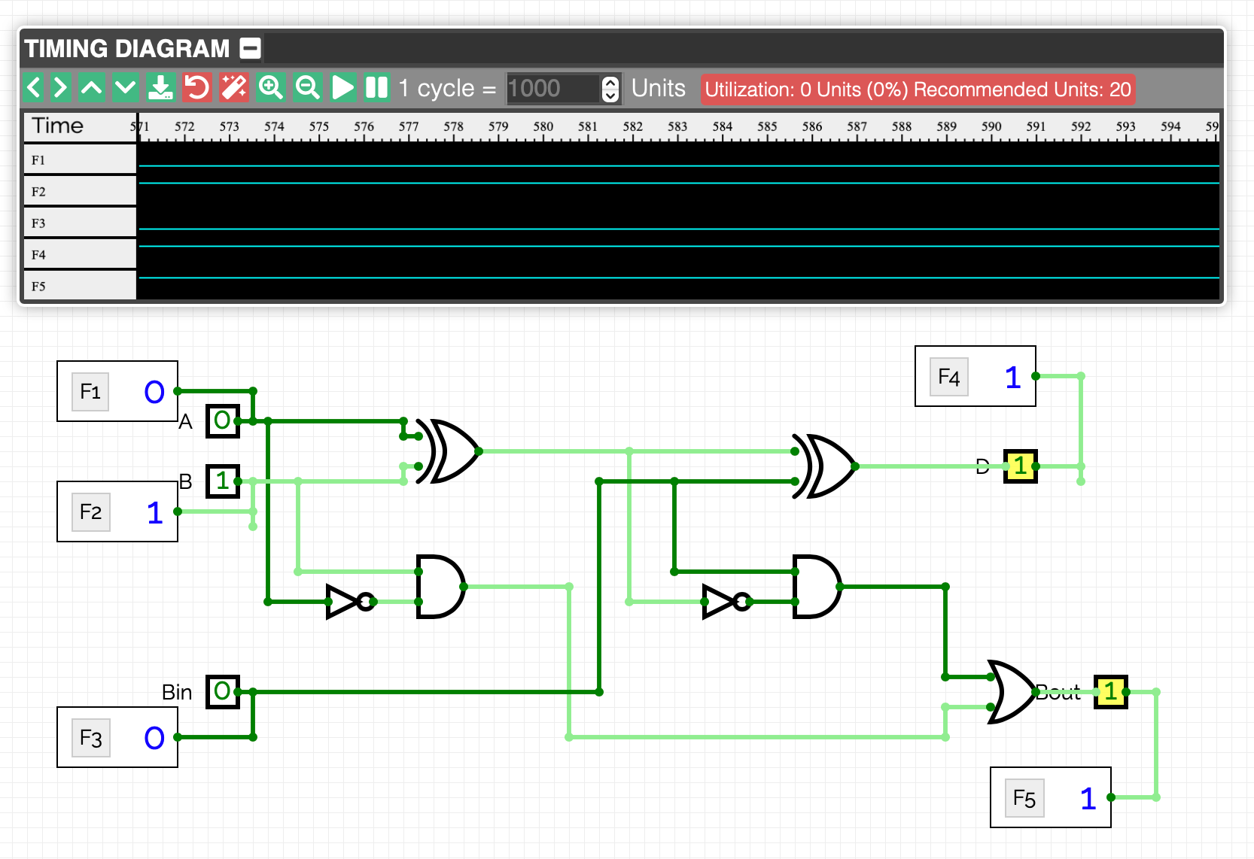
RESULT:

(Full-subtractor combinational circuit using AND and XOR gates)

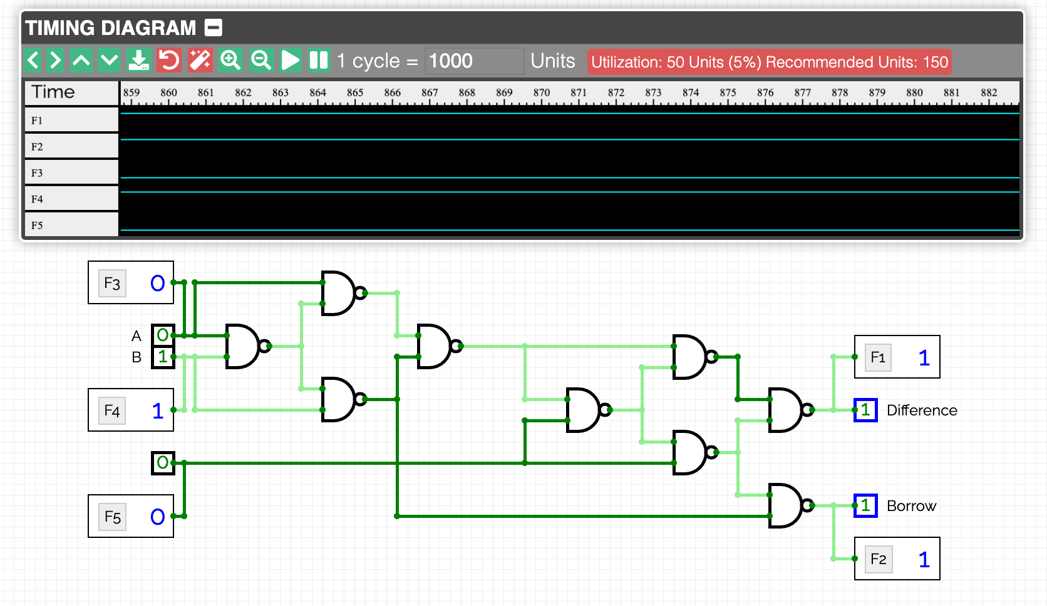
Bin

(Full-subtractor combinational circuit using NAND gates)

Conclusion: Half-subtractor and Full-subtractor combinational circuits have been successfully constructed.

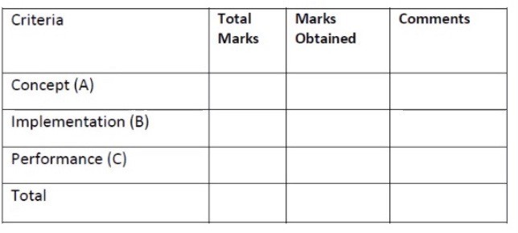

EXPERIMENT: 4

AIM: To implement a 4-bit binary adder-subtractor circuit.

PLATFORM/TOOLS USED:
Circuitverse.org

THEORY:
A Binary Adder-Subtractor is capable of both addition and subtraction of binary numbers in one circuit itself. The operation being performed depends upon the binary value the control signal holds itself. It is one of the components of the ALU (Arithmetic Logic Unit).

CIRCUIT DIAGRAM:
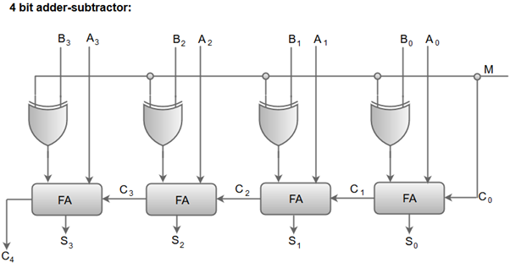

- When the mode input (M) is at a low logic, i.e., '0', the circuit act as an adder and when the mode input is at a high logic, i.e., '1', the circuit act as a subtractor.
- The exclusive-OR gate connected in series receives input M and one of the inputs B.
- When M is at a low logic, we have B⊕ 0 = B.
The full-adders receive the value of B, the input carry is 0, and the circuit performs A plus B.
- When M is at a high logic, we have B⊕ 1 = B' and C0 = 1.
The B inputs are complemented, and a 1 is added through the input carry. The circuit performs the operation A plus the 2's complement of B.
TRUTH TABLE
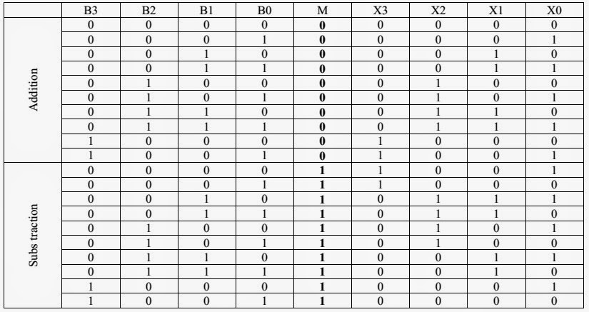

RESULT:
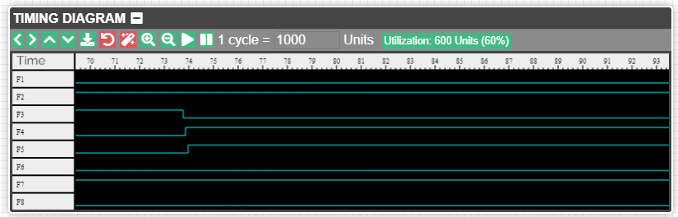
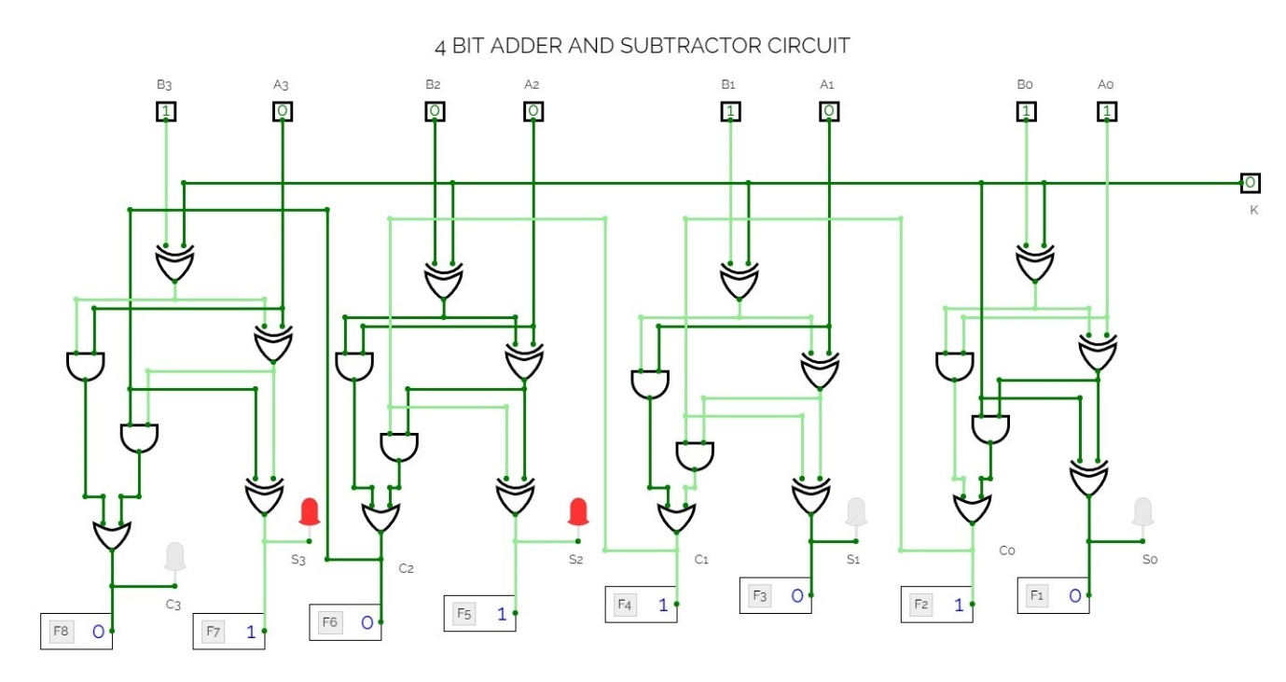

CONCLUSION: The 4-bit Binary Adder-Subtractor combinational circuit has been successfully constructed.

EXPERIMENT: 5

AIM: Construction of Arithmetic Logic Unit using:
- 4:1 Multiplexer.
- Decoder

PLATFORM/TOOLS USED: circuitverse.org

THEORY:

ALU is a main component of the central processing unit, which stands for arithmetic logic unit and performs arithmetic and logic operations. It is also known as an integer unit (IU) that is an integrated circuit within a CPU or GPU, which is the last component to perform calculations in the processor. It has the ability to perform all processes related to arithmetic and logic operations such as addition, subtraction, and shifting operations, including Boolean comparisons (XOR, OR, AND, and NOT operations). Also, binary numbers can accomplish mathematical and bitwise operations. The arithmetic logic unit is split into AU (arithmetic unit) and LU (logic unit).
Truth table for ALU:

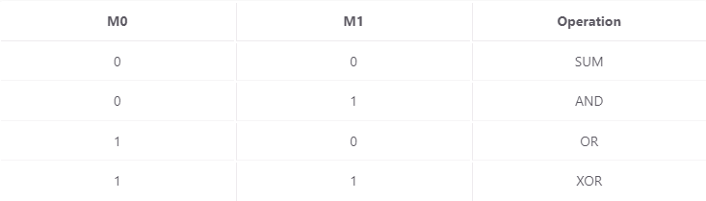

Simple Circuit Implementation:
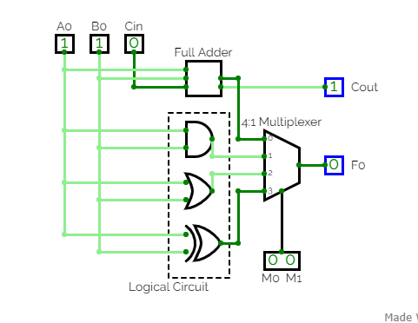

RESULT:

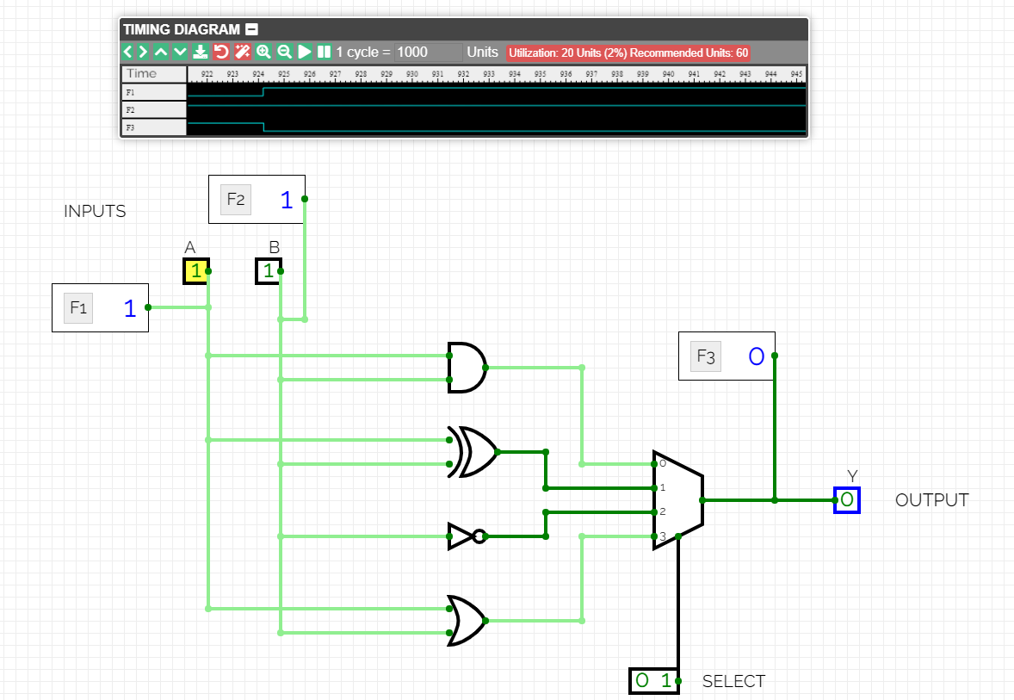

(Construction of ALU using Multiplexer)

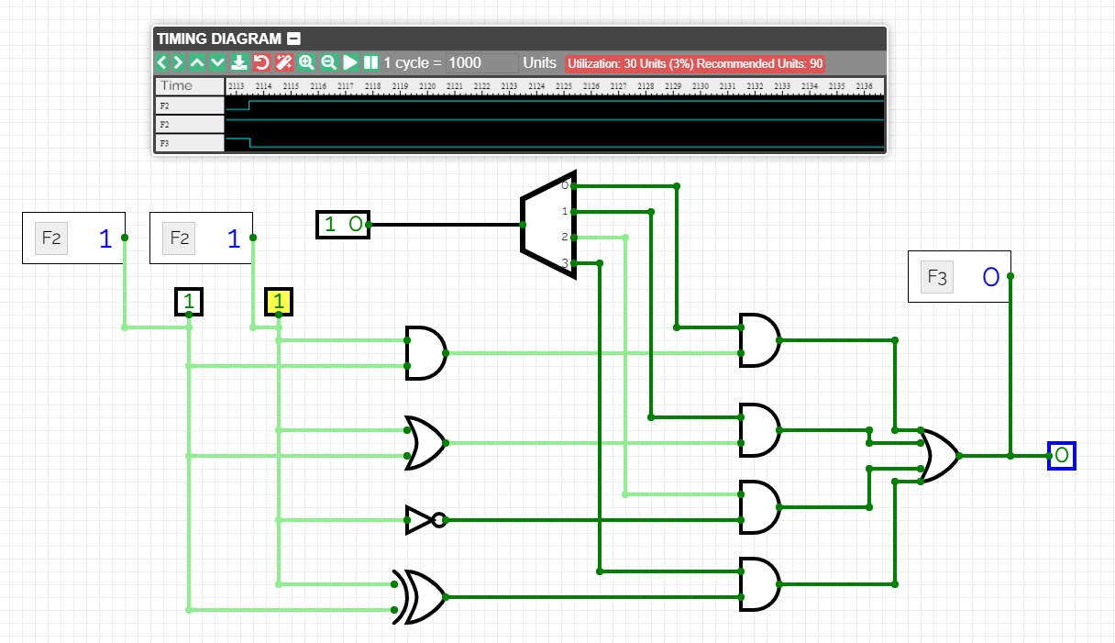

(Construction of ALU using Decoder)

Conclusion: Arithmetic Logic Unit has been successfully constructed.

CRITERIA | TOTAL MARKS | MARKS OBTAINED | COMMENTS
Concept (A) | 2
Implementation (B) | 2
Performance (C) | 2
TOTAL | 6

